Chapter 3: The Five Rules to Managing Career Anxiety
Stephen Flach’s life hit an all-time low when he broke both his fucking arms during a bike ride during the tail end of his alcoholism, forcing him to end his contract work with various non-profits and prompting him to quit his master’s degree, after having played in an indie band and taking up part-time jobs for the past decade.

During a point in life where he desired stability, chaos ensued: after recovering from his injuries, he’d eventually break his right arm again just a few years later, putting him out of commission once more. Yet today, through all his adversities, he’s been one of the most successful and career-fulfilled people I’ve known, with a journey only one can look back upon with a smile. Having suffered through a life spanning galaxies I never imagined one could travel through, let’s start this book with exactly that: his unimaginable journey.

Stephen was a drummer for an indie punk band named Submission Hold, which he toured around the world with from 1993 until 2005.

Prior to this, he didn’t graduate from high school. Instead, he worked a year at a fishing factory, tending to machines and perhaps smelling like fish every night he returned to bed.

During the last few years of his journey as a musician until his university days, he became a mental health worker for a non-profit in Vancouver’s grimiest neighborhood. From frontline service work to community, social, and organizational support, he did it all.

Then he returned to school for a bachelor’s degree in communication at Simon Fraser University (SFU). Throughout his undergrad and even after, he also held temporary contract roles in the community and social organization space.

During his studies, he held various positions at SFU and Langara College, marking a transition to the academic world. These included being a research assistant, teaching assistant, and even assisting in the chair of physics at SFU after he graduated.

Then he ventured into startups, dabbling with VR technology while running another business reselling vintage goods.

Finally, he landed his foot at Mozilla, where he became a senior project and product manager for their VR and enterprise application solutions. He also helps run meditation retreats on the side being a mindfulness instructor after having practiced meditation for years.

I could get into a whole book-length biography about the damn guy, but for the sake of our story, let’s focus on his astonishing career path that seems as striking as it does non-linear.

Submission Hold was a punk rock band that originated in East Vancouver, Canada, and ended up touring around North and South America and Europe. They released some incredibly experimental music—dabbling with hardcore punk and post-genre sounds, combined with anarchist and feminist lyrics that truly made them unique in the scene. They released emotionally attaching tunes that generated niche audiences from around the world. They did what so many aspiring indie bands and musicians hope to accomplish: live out their dream, touring the world with their beautiful melodies while touching countless hearts in the process.

Traveling around the world in a van to tour isn’t exactly par for the course for an indie band, but the core members of the band from when they disbanded—Jen Thorpe, Andy Healey, and Stephen Flach—refused to let the risk of failure deter them from their aspirations. They lived a life not many are able to experience, and don’t have any regrets. On the side, because of the harsh nature of music labels and indie band production, all band members worked part-time jobs—mostly in the fields of community service, among others—to make ends meet.

Sure, they lived paycheck to paycheck and suffered from an unstable quality of life, but they knew what they were getting themselves into, and had the support of thousands. They didn’t buy goods and rent experiences. They rented goods and bought experiences. Not many—especially if we’re early in our careers—know what we want in life. We also don’t know what we don’t know. We chase intuitions and let external factors dictate our paths. But Stephen not only took a risk to chase a passion he doesn’t regret, he always found ways to expand his skillset and career through various challenges or adversities, whether in the arts or not.

Despite the outside success exhibited by Submission Hold, Stephen himself suffered from personal and professional adversities throughout his adulthood. As mentioned, he suffered from alcoholism at various periods of his life, both before, during, and after his musical tenure. He once got into a bike accident that broke not one but both his arms, rendering him useless for weeks and throwing his career into question. Not only did he quit his master’s program after life priorities shifted his mindset, but he broke his arm again just a few years later.

Recovering from both arm injuries and alcoholism as well as learning to manage his ADHD, among other complications, didn’t deter him; in fact, it practically reset his entire life outlook in a way that allowed him to treasure everything he has. He turned these experiences into learning lessons that shaped his identity and made him the ambitious, hard-working man he is today. He realized—like many of us when we get into accidents—just how important it is to keep ourselves healthy, both physically and mentally. Alongside his recoveries, Stephen did the due diligence of adopting meditation as a mental health adjustment to truly establish self-awareness and tranquility. This, combined with his social work experience, allowed him to truly appreciate what life offered him. All of these efforts to take care of his body were instrumental in improving the other parts of his career after graduating, which we’ll now get to.

Stephen handpicked a few core crafts that he knew he excelled in, such as business analytics, community management, audio producing, and project management. He had handled a lot of project-management-related tasks already when he was part of Submission Hold, such as booking venues, managing schedules, bookkeeping, and contacting stakeholders. He also developed fundamental business analysis experience during his time contracting for various organizations after his musician days.

After graduating from his undergrad, Stephen focused on mastering his horizontal skills (like interpersonal and fundamental skills) first instead of worrying about vertical domain knowledge. He may have suffered episodes of anxiety or hardship throughout his life, but because of that experience, he always tackled new opportunities with a fresh mindset, knowing things would be OK since his tolerance had been trained. When he told me about his second arm-breaking accident, I was shocked by his story.

“My arm was practically broken off from the rest of my body,” he explained as I squinted my eyes to prevent intrusive imagery. “But I was calm. Normal people would’ve screamed. I kinda just laid there and stayed calm. Both the paramedics and the doctors were surprised at how calm and quiet I was.”

“After all that you’ve gone through, I guess nothing phased you.”

Upon entering academia to continue his work in business analysis and project coordination, Stephen established financial stability. Then, he moved to Langara College to further his experience, and joined a startup thereafter with his transferable skills. Through this trek, Stephen demonstrated his ability to explore opportunities, and looked for ways he could expand his skills and knowledge in adjacent areas.

He engaged in communities (I met him through one of the first events I hosted for my community, PM Hive), learned to treasure his social bonds, and built a strong network of friends and peers who supported him the best way they knew how.

All his experience culminated in his success today at Mozilla, and he’s content with the hardship he’s experienced. It’s built a lot of different skills that he didn’t realize he was developing, and his ability to stay stoic yet ambitious is the result of his past. This is an example of a career that leaves one all misty-eyed when reflecting back once it’s time to hang the boots up. But what can we learn from Stephen’s story that we can apply to ourselves?

First, let’s step back for a second. Ask yourself: if you ever had the opportunity to eliminate all social, cultural, family, and financial expectations out of your career-decision-making process, what does that leave you? If you had all the time in the world, what would you attempt to achieve and thrive with?

Would that job or career be the same as the current career you’re thinking about or poised to undertake?

Chances are, they’re probably not; even if they are, that doesn’t guarantee your happiness and fulfillment in the long term, either. So if your answer is no, that probably means that you’d rather take something above what you’re currently on the path toward. So if that’s the case, this book and its soon-to-be-introduced framework will help with achieving a dream that combines both what you’re doing today with what you dream of doing in the future.

Perhaps for some, a dream career would be to become a freelance artist. For others, it could be starting a business that they’re passionate about. Maybe a few would want to become a famous chef; if not, maybe an author, astronaut, or rocket scientist. Or, like Stephen, the dream of touring in a band is still alive for the rest. But how do we chase those passions while managing our anxieties?

Of course, the reality is that if people only chase their passion and ignore all other aspects of what defines a good career, they could be setting themselves up for failure. Passion-based aspirations are only one slice of the pie—chasing them for a career could make us feel temporarily fulfilled, but we would be missing all other angles of the Ikigai Venn Diagram—a recipe for long-term happiness.

Ikigai—a philosophy and concept adopted by the Japanese that highlights how one can find their true purpose in life through multiple intersections (like passion, vocation, and demand), is one such method to consider when trying to reduce career anxiety.

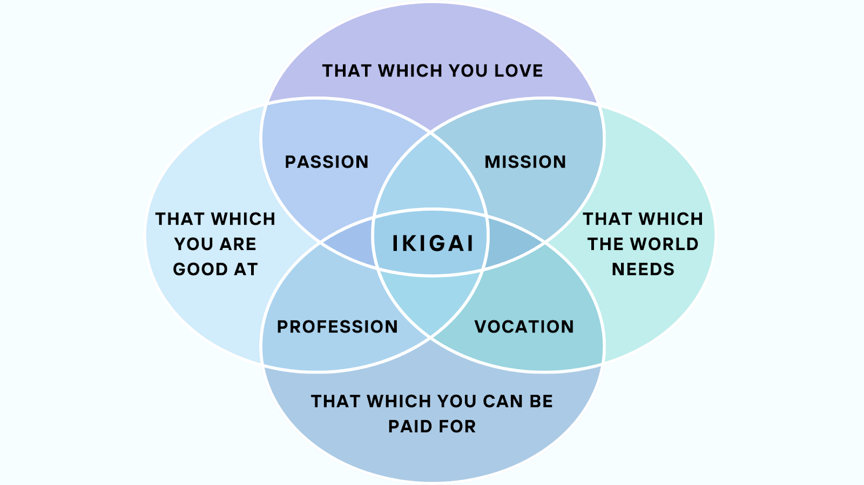

As you can see, the ikigai diagram explains how the goal would be to land in the middle: a career path that blends passion with financial stability, adequate skill, and market demand.

While we will reference this concept from time to time, it’s important to know that in order to achieve such a state, your career anxieties and obstacles must be quashed, and the right methodologies must be applied to ensure you’re on your way to achieve your dream career.

This is where Stephen’s story introduces the framework I have: DREAM. The DREAM framework is one I’ve developed after countless interviews with diverse work professionals, research, and experiences to understand the best set of rules to set anyone up for success. It serves to help anyone find their step in a world full of millions of paths and dreams, in such a way where it prioritizes their well-being, sets themselves up for financial stability, and aligns their career with their passions and interests.

DREAM: The five rules to conquering all career anxiety, achieving financial freedom, and becoming a passion superstar.
D: Do yourself a favor
R: Relentlessly grow
E: Embrace suffering
A: Adjacent Skills are Possible
M: Make yourself engaged

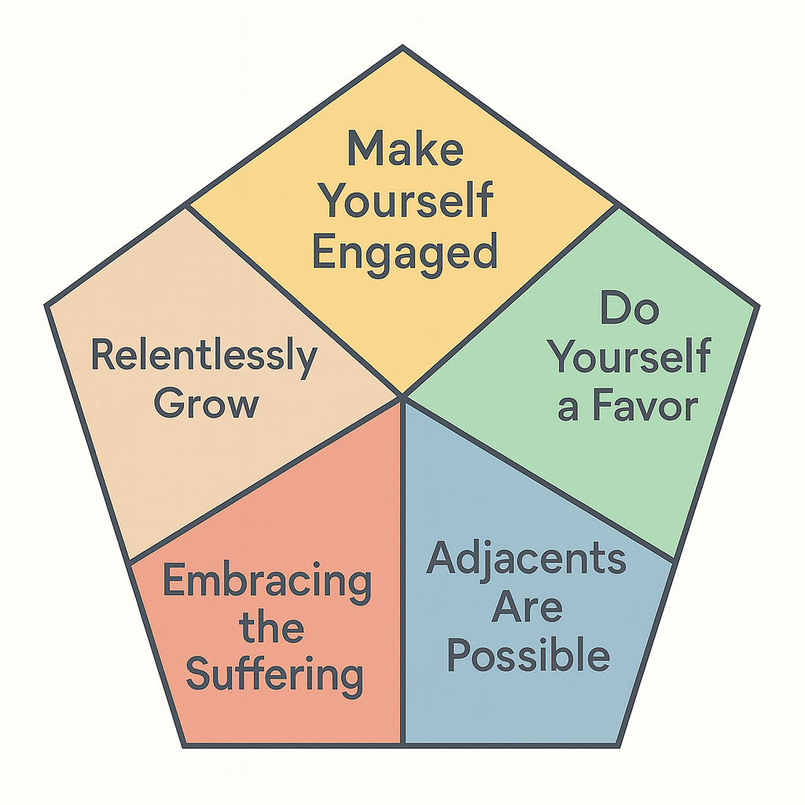

But I know it’s not easy; no real problem in life has its easy fixes. Every individual boasts unique circumstances and requirements, so I’m not going to sugarcoat a heist that leaves you fawning with dollar signs and heart emojis spilling out of your mouth. If such a solution existed already, then no one in the world would suffer from passion- and career-induced anxiety. Instead, I’m proposing my own ideas, with a brush of realism and practicality.

My goal with these five rules in the DREAM framework is to simply unleash a guiding set of principles that each reader can apply at their own levels where comfortable, and empower everyone to set themselves up for career success—a passion-led path that somehow finds itself immersed in fulfillment.

Stephen unknowingly leveraged the DREAM framework for his own career path to find the success he has today. So let’s dive into each one and come back to Stephen’s story at the end of this book.

